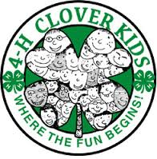
Shelby County 4-H Clover Kid Award Form

First and Last Name: ______________________________________________________

4-H Club:_______________________________________________________________

4-H Age:________ Year in Clover Kids: ________
Tell us what you did this year as a Clover Kid. Such as items made for the fair, contests you participated in at Achievement Day, county activities you attended such as clover kid’s camp, skating party etc.
____________________________________________________________________________________________________________________________________________________________
________________________________________________________________________________________________________________________________________________________________________________________________________________________________________________________________________________________________________________________________________________________________________________________________________________________________________________________________________________________________________________________________________________________________________________________________________________________________________________Due September 20th

